Come and Sing
Sat 26th September
Beethoven: Missa Solemnis

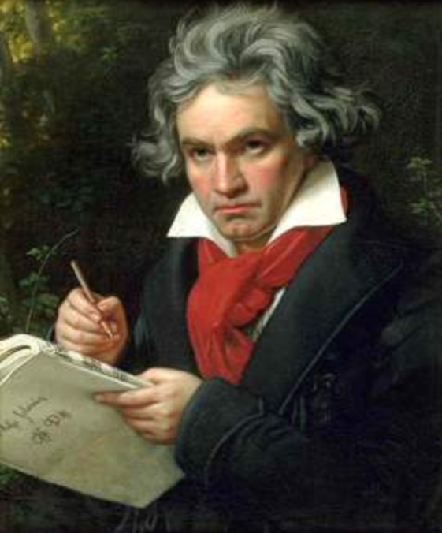

Conductor: Tom Hammond-Davies
Accompanist: Simon Howat

The Beaconsfield School, Wattleton Road, Beaconsfield, HP9 1SJ

Registration from 9:45am for 10:30 downbeat; Performance 5-6:30 pm

Tickets: £20 (£15 group rates, students £5) includes coffee / tea, and loan of score if required

Ploughman’s Lunch option available for £6 (must be pre-booked and prepaid by 21st Sept)

To register, please email the completed form to ComeandSing@wooburnsingers.org.uk & arrange online payment to Wooburn Singers, sort code 30-96-54, account no. 01029546. Please quote C&S as the reference.

Alternatively, post the form below to:
Caroline Robson, 4 Top Farm Close, Beaconsfield HP9 1JS
enclosing a cheque payable to Wooburn Singers

For more information & map go to www.wooburnsingers.org.uk

*****************************************************************************************
Wooburn Singers – Missa Solemnis: Come & Sing Registration

Name: _______________________________ Choir____________________

Email: _______________________________ Phone: ___________________

Address: (only need if no email address)___________________________________

___________________________________________________________

Voice Part: S A T B / 1st / 2nd (delete as appropriate)

I need to borrow a score (Novello) / I have my own (delete as appropriate)

Payment: __ tickets at £20 / __ student tickets at £5 £_______
__ Ploughman’s lunches at £6 £_______
Paid online / Cheque enclosed (delete one) total £_______

