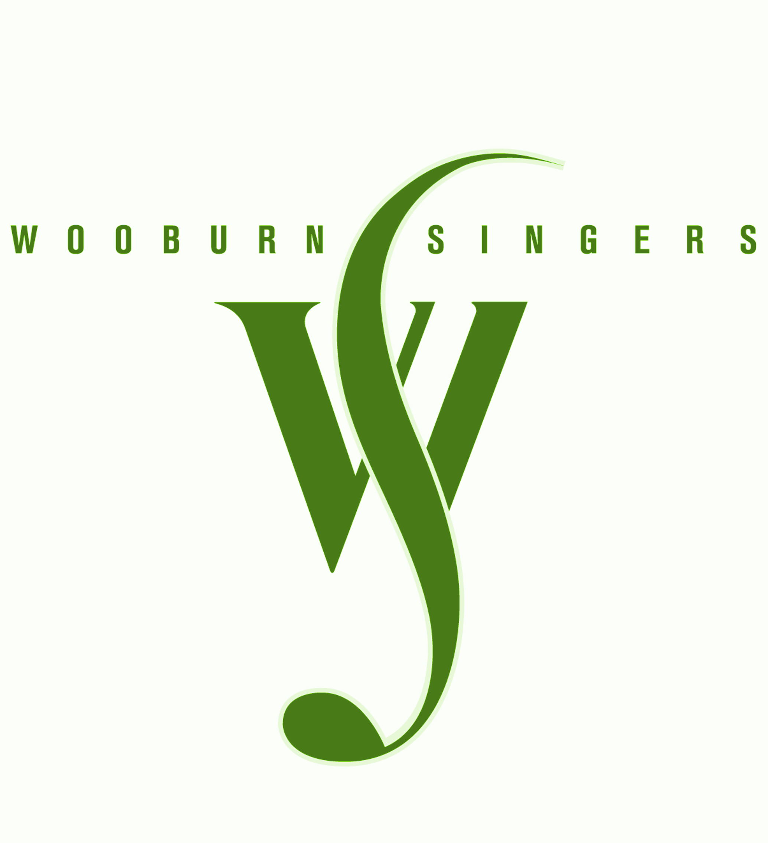
Season 2016-17

2016 - 17 | Programme | Venue
1st Oct 2016 | Come and sing  Haydn: The Creation | Challoners High School,  Little Chalfont
22nd Oct 2016 | Handel: Zadok the Priest  Haydn: London Symphony  Vaughan Williams: Serenade to Music  Villa Lobos: Bachianas Brasileiras No 5  Mozart: Coronation Mass | Buckingham New University,  HighWycombe  (+New Mozart Orchestra, Wooburn Festival 50th anniversary Gala Concert)
17th Dec 2016 | Christmas Music for choir and audience | St Mary’s Church, Beaconsfield
28th Jan 2017 | Come and Sing  J S Bach: Magnificat | Wycombe High School,  High Wycombe
11th Mar 2017 | Bruckner motets | St. Teresa’s Church,  Beaconsfield (+ Onyx Brass)
17th June 2017 | Wooburn Singers’ Greatest Hits: 50th anniversary concert with past conductors & singers | All Saints Church, Marlow  & party afterwards

